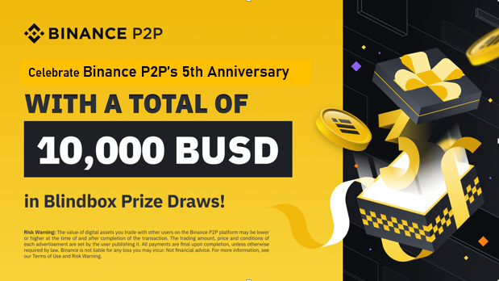

Celebrate Binance P2P’s 6th Anniversary

**Celebrate with Binance P2P: Share in a 10,000 BUSD prize pool on our Gift Card Marketplace (Only on Binance App)**

Few days left to celebrate Binance P2P turning five, all new and existing Binance P2P users who visit the Gift Card Blindbox Page during the participation period and purchase a **P2P 5 Year Anniversary Gift Card Blindbox** worth at least 1 BUSD as their Participant Ticket stand a chance to share in a total of 10,000 **BUSD** in rewards.

**Ten winners** will be selected based on BNB Chain Hash Value Selection Criteria to get **1,000 BUSD each**. For non-winners, the participation cost of 1 BUSD is 100% refundable!

**Participation period: 2023-06-16 00:00 (UTC) – 2023-06-26 23:59 (UTC)**

**How to participate:**

Step 1: Visit the Blingbox.com. **(Binance App only)**

Step 2: Click the **“Participate Now”** button at the button the page.

Step 3: Purchase a P2P 5 Year Anniversary Blindbox Gift Card for 1 BUSD.

Step 4: Wait until the claim reward starts, then click to check your **Blindbox reward results.**

Step 5: If you’re one of the winners, please go to the “User” tab to redeem your prize. For all non-winners, your **1** **BUSD** participation cost will be refunded **as a P2P 5 year anniversary Gift Card to your account.**

“This promotion is only available on **Binanace App**. Please head to the “profile” section in the Binance App, and tap on the “Gift Card” icon to order the **Gift Card Mini App >** click “P2P 5 Year Anniversary Blindbox campaign”.

**Participate Now**

Social media handles